RESOLUTION 2021-06

A RESOLUTION OF THE BOARD OF SUPERVISORS OF THE CORAL KEYS HOMES COMMUNITY DEVELOPMENT DISTRICT ADOPTING THE CLUB KEYS POINTE RULES AND REGULATIONS, AND ADOPTING THE SCHEDULE OF HOURS OF OPERATION, DUES, FEES AND CHARGES, RENTAL AREAS & FEES, RENTAL POLICIES, PROCEDURES AND REGULATIONS, AND ADDITIONAL RULES PERTAINING TO FACILITY RENTAL AND PROVIDING FOR AN EFFECTIVE DATE.

WHEREAS, the Coral Keys Homes Community Development District (the "District") is a local unit of special purpose government created and existing pursuant to Chapter 190, Florida Statutes, being situated in unincorporated Miami-Dade County, Florida; and

WHEREAS, the District has approved the acquisition of the Club Keys Pointe clubhouse and related facilities ("Club Property"); and

WHEREAS, pursuant to Section 190.011, Florida Statutes, the District is authorized to adopt and modify rules, regulations, and rates pursuant to the provisions of Chapter 120, Florida Statutes, prescribing the conduct of the business of the District; and

WHEREAS, Section 190.035, Florida Statutes, authorizes the District to prescribe, fix, establish, modify, and collect rates, fees and other charges for facilities and services furnished by the District; and

WHEREAS, the District has complied with the provisions of Chapter 120, Section 190.011, and Section 190.035, and has conducted a public hearing to address the adoption of the Club Keys Pointe Rules and Regulations and the Schedule of Hours of Operation, Dues, Fees, and Charges, Areas & Fees for Rental, Rental Policies, Procedures and Regulations, and the Additional Rules Pertaining to Facility Rental, as contemplated herein.

NOW, THEREFORE, BE IT RESOLVED BY THE BOARD OF SUPERVISORS OF THE CORAL KEYS HOMES COMMUNITY DEVELOPMENT DISTRICT, THAT:
Section 1. The foregoing recitals are hereby incorporated as the findings of fact of the District Board of Supervisors.

Section 2. The following are hereby adopted by the Coral Keys Homes Community Development District:

- Club Keys Pointe Rules and Regulations, a copy of which is attached hereto and incorporated herein as Exhibit "A";

- Schedule of Hours of Operation, a copy of which is attached hereto and incorporated herein as Exhibit "B'';

- Dues, Fees, and Charges, a copy of which is attached hereto and incorporated herein as Exhibit "C";

- Facility Rental Fees and Deposits for Rental, Rental Policies, Procedures and Regulations, and the Additional Rules Pertaining to Facility Rental, attached hereto and incorporated herein as Exhibit "D"

(collectively referred to as the "Club Rules").

Section 3. The District Manager shall include the Club Rules, as each may be amended from time to time, in the Official Records of Proceeding of the District.

Section 4. The District Manager is hereby directed to take all actions consistent with this Resolution.
Section 5. All Resolutions or parts of Resolutions in conflict herewith are hereby repealed to the extent of such conflict.
Section 6. If any clause, section or other part or application of this Resolution is held by a court of competent jurisdiction to be unconstitutional or invalid, in part or as applied, it shall not affect the validity of the remaining portions or applications of this Resolution.

Section 7. This Resolution shall take effect upon the conveyance of the Club Keys Pointe Clubhouse and related facilities to the District.
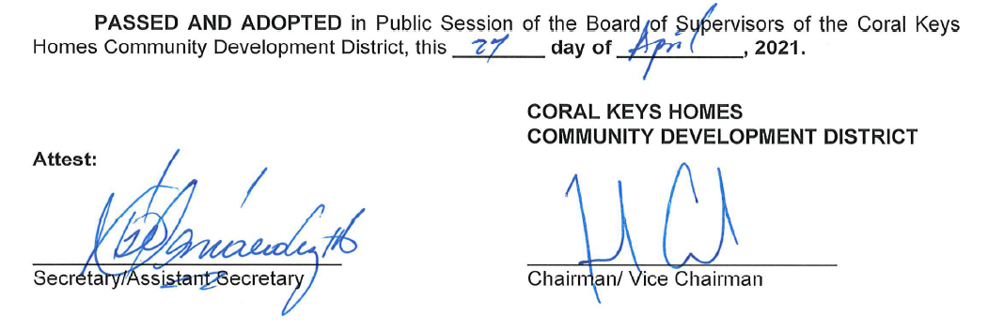

2

